#LetAdrienEat2k16

GAME DESIGN DOCUMENT

Prepared by

Marienne Louane D. Lopez  
11322071  
GAMEDEV X23  
February 17, 2016

**TABLE OF CONTENTS**

# Chapter 1 – Overview: p. 3

# Chapter 2 – Background story and flow: p. 4

# Chapter 3 – Game play: p. 5

# Chapter 4 – Elements: p. 6

# Chapter 5 – I/O controls and GUI interfaces: p. 7

# Chapter 6 – Visual and audio features

# Chapter 7 – Concept Art: p. 8

**CHAPTER 1**

**OVERVIEW**

1. **Title:** #LetAdrienEat2k16
2. **Genre:** Casual, arcade game
3. **Perspective:** Third person
4. **Game mode:** Single player, one level
5. **Target audience:** everyone

**CHAPTER 2**

**BACKGROUND STORY AND FLOW**

1. **Setting:** Adrien Agreste’s dream/ nightmare.
2. **Main playable character:** Adrien Agreste  
   Adrien Agreste is a French high school boy. He’s known

**CHAPTER 3**

**GAMEPLAY**

The only character in this game is the snake, the sole moving character in this game. The character can be move around the environment, eat food and get killed in one of two ways, as explained in the last chapter, by bumping into obstacles or eating one’s own body. When the snake eats the food in the game, it grows longer. It moves by going up, down, left or right in the environment, trying to avoid the obstacles and eat the food.

There are two designs for the snake. The first design included one image for the body and two images for the head. The first image of the head will be used when before and after it has eaten the food while the second image will be used when it’s about to eat the food (see Fig. 1 in Concept Art). The second design uses only one sprite (see Fig. 1-b in Concept Art) to represent the entire snake from the head to its body.

**CHAPTER 4**

**ELEMENTS**

As mentioned in the previous characters, the player plays a snake eating food and avoiding obstacles. However, a special food is also mentioned. This ‘special food’ not only makes the snake longer after it eats it, it transports the snake to a different level and changes the speed of the snake before playing. This variation of the game intends to test the player’s hand-eye coordination and strategy. The player has to strategize on how to move the snake in order to avoid the obstacles in the levels. The player also has to take note of when to go up, down, left or right depending on the current snake’s speed to be able to grow longer and/or reach the next level. When the player goes to the next level, his/her character’s snake would still be in the same length so strategy also takes in here because the player would want a slower snake and an easier level, which can only be randomly generated during the game.

The game ends when the snake eats the last food which will fill up the snake in the entire level. Every time the snake eats food, a point will be gained. The accumulated points would be synonymous to how much the snake has filled the level. When the player has accumulated a certain number of points, the game ends satisfyingly. A high score is also set in order to motivate the player to beat it.

**CHAPTER 5**

**I/O CONTROLS AND GUI INTERFACES**

Each level the player may encounter in the game is a variation to a pattern of walls placed accordingly onto a black background. The walls appear to be different every time the snake teleports to another level through its color and two successive levels do not have the same colored walls, indicating the change in environment. Also, with the addition of the ‘special food’, the snake’s speed may also change, which will give each level additional difficulty as the player would have to cope with fundamental changes which may hinder the player from finishing the game.

**CHAPTER 6**

**VISUAL AND AUDIO FEATURES**

Each level the player may encounter in the game is a variation to a pattern of walls placed accordingly onto a black background. The walls appear to be different every time the snake teleports to another level through its color and two successive levels do not have the same colored walls, indicating the change in environment. Also, with the addition of the ‘special food’, the snake’s speed may also change, which will give each level additional difficulty as the player would have to cope with fundamental changes which may hinder the player from finishing the game.

**CHAPTER 7**

**CONCEPT ART**

**snake.png**



*Fig. 1. Snake images to be used.*

*Fig. 1-a. The one on the left was the original design and will be used when the snake is*

*about to eat the food.*

*Fig. 1-b. The one on the right is a simplified sprite to represent the entire snake from head to body.*

**snake_food.png**



*Fig. 2. Food images to be used.  
Fig. 2-a. The one on the left represents the ‘special food’ in the game.  
As explained in the previous chapters, the snake will be teleported to a new level and have its speed changed when it eats this.  
Fig. 2-b. The one on the right represents the ‘regular food’ in the game.*

**wall2.png**



*Fig. 3. Wall images to be used.  
These are to be used to represent different levels in the game. A different design and/or color can be applied to create more walls if necessary.*

**help.pngpause.pngrestart.png**

*Fig. 4. Other controls of the game.  
Fig. 4-a. The leftmost image represents ‘help’, which will show the instructions screen when the player presses the ‘H’ button on his/her keyboard.*

*Fig. 4-b. The image in the center represents ‘pause’, which will pause/unpause the game when the player presses the ‘P’ button on his/her keyboard.*

*Fig. 4-c. The rightmost image represents ‘restart’, which will restart the game when the player presses the ‘R’ button on his/her keyboard.*

**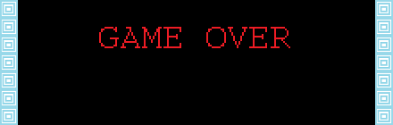**

*Fig. 5. The ‘Game Over’ screen. This will appear when the player either lets the snake bump into an obstacle or eat itself. The player has to press ‘R’ in order for this message to go away and to restart the game in the process.*

****

*Fig. 6. A draft of a level in the game. The wall sprites are added to a black background to create semblance of ‘obstacles’ without separately adding the game. This is the first version of the level design, the second would involve inserting the wall images programmatically and only include a black background.*

**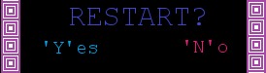**

*Fig. 7. This image will popup when the player presses the ‘R’ button on his/her keyboard, opting to ask the player to make sure that they want to restart. If he/she pressed ‘Y’, the game will restart. If he/she pressed ‘N’ , it will return to the paused version of the game where he/she can resume by pressing ‘P’.*

**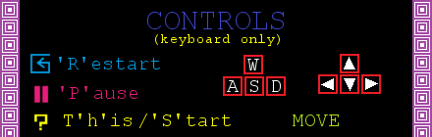***Fig. 8-a. This will appear when the player presses ‘H’ any time during the game. This is a draft of the actual help screen to be shown to the player before he/she starts the game which eventually became a separate image as seen below in Fig. 8-b.*

**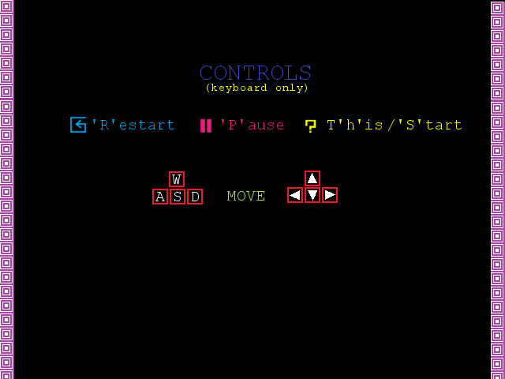***Fig. 8-b. The instructions screen shown to the player before the game actually starts. Notice that there is no indication of which is the ‘special food’ and the ‘regular food’ because it is necessary for the player to discover it while playing as a form of exploration as well.*